Ephesians: The Riches of God's Grace and the Life of His Church
  - Introduction — The City, the Apostle, the Church, and the Eternal Purpose of God

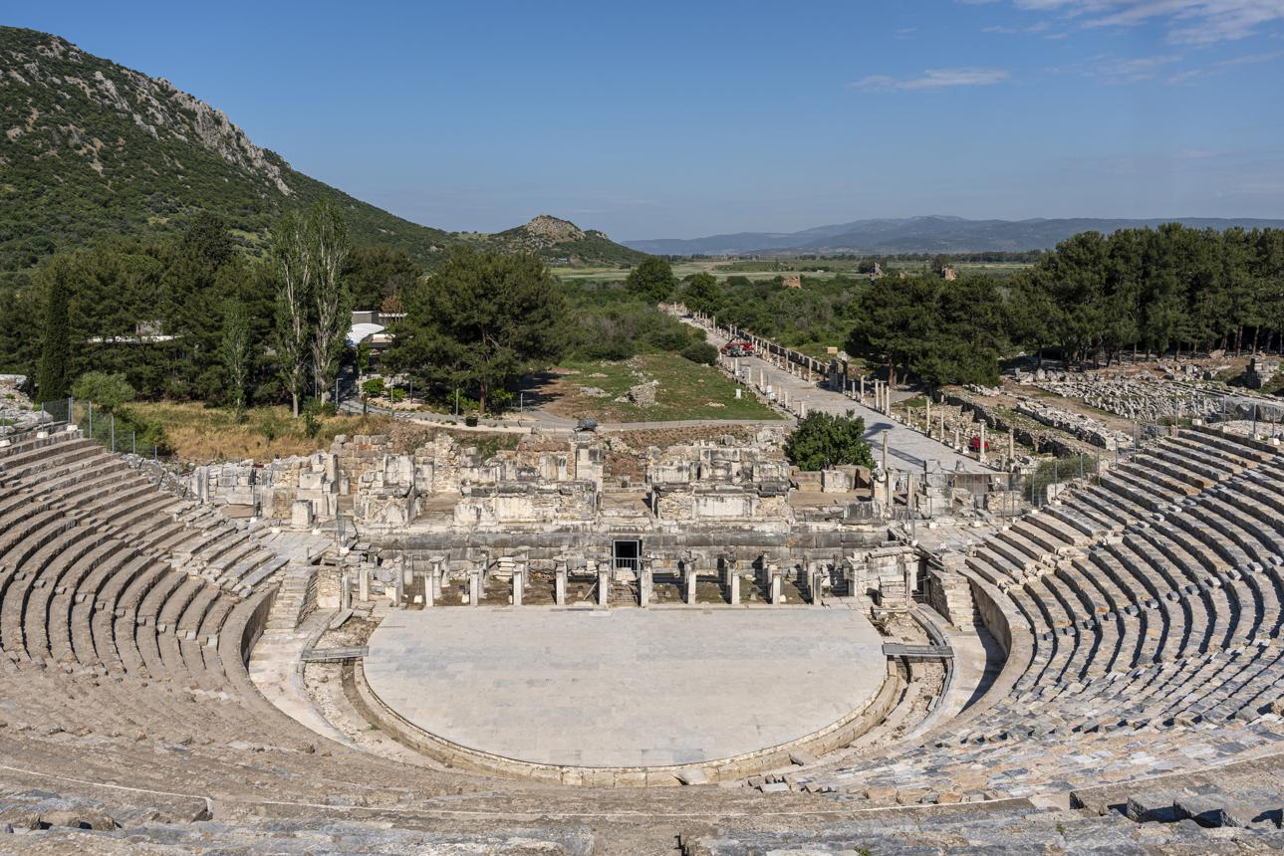
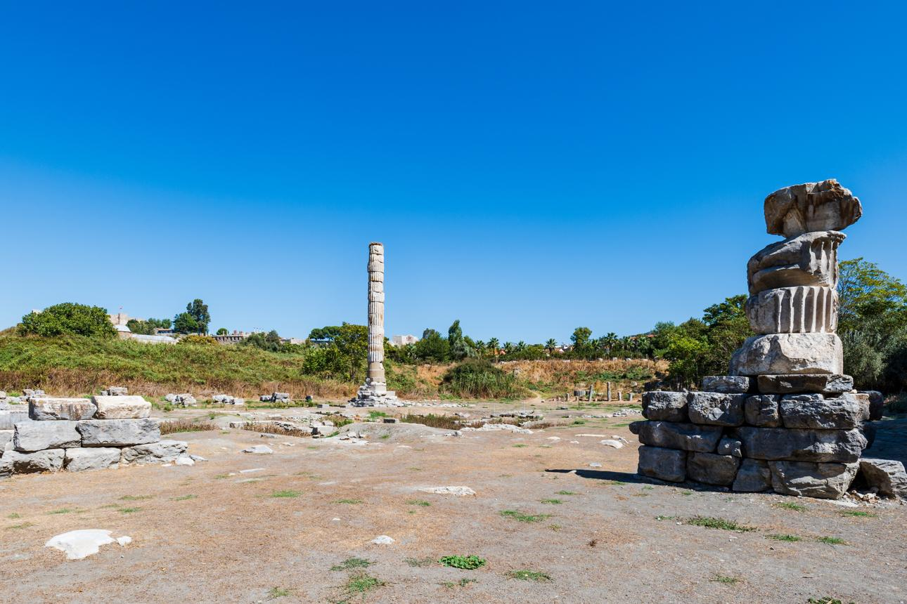

Introduction: A Letter That Begins in Eternity and Ends in Everyday Life
Among the writings of the apostle Paul, the letter to the Ephesians occupies a distinctive place because of the breadth of its theological vision and the practical consequences that flow from it. While Romans develops an extensive argument concerning sin, justification, faith, and the righteousness of God, and Galatians vigorously defends the gospel against those who would place Gentile believers under the obligations of the Mosaic Law, Ephesians directs the reader toward the eternal purposes of God and the remarkable position of the church within those purposes. Paul begins before the world was created, describes the redemptive work accomplished through Jesus Christ, and then brings those eternal realities into the ordinary relationships and responsibilities of Christian life.
The movement of the letter is extraordinary. It begins with believers being chosen in Christ before the world was created and concludes with believers standing resolute when confronted by the devil’s schemes. Between those two points, Paul explains the riches of divine grace, the reconciliation of Jews and Gentiles, the unity and maturity of the church, the transformation of Christian character, and the responsibilities that accompany life in Christ. His concern is not merely that believers understand what God has done, but that they recognize how their new identity must shape their conduct.
This relationship between theological truth and practical obedience provides one of the essential interpretive principles for studying Ephesians. Paul does not begin by telling Christians what they must accomplish in order to obtain God's favor. Instead, he explains what God has already accomplished through Christ and then calls believers to live in a manner consistent with that reality. The commands of chapters 4–6 rest upon the declarations of chapters 1–3. Christian conduct is therefore presented not as the means by which salvation is earned, but as the appropriate expression of a life transformed by grace.
Understanding this progression requires more than an examination of individual verses. Ephesians must be read as a coherent literary and theological work, written within a particular historical setting and addressed to believers whose experience of the gospel was unfolding within the religious, cultural, and social world of the Roman Empire.

1. Ephesus: A Major City of Roman Asia
Ephesus was one of the most prominent cities in the Roman province of Asia, located near the western coast of what is now Turkey. Its importance rested upon a combination of geography, commerce, political influence, and religious activity. Although the city had a long history extending back into the Greek world, it flourished during the Roman period as a major urban center and an important point of connection between the Aegean maritime world and the inland regions of Asia Minor.

The city's harbor and commercial routes contributed to its prosperity, while its public buildings, theaters, marketplaces, and religious structures reflected the wealth and cultural sophistication of Roman urban life. Ephesus was not an isolated provincial community in which Christianity developed apart from the larger world. It was a city where ideas, religions, economic interests, and political loyalties intersected, creating both opportunities and opposition for the proclamation of the gospel.
One of the most striking features of Ephesian religious life was the prominence of Artemis, whose sanctuary was counted among the celebrated Seven Wonders of the ancient world. The Ephesian form of Artemis worship was deeply connected to the city's identity, and devotion to the goddess carried social and economic significance beyond the private religious practices of individual worshipers. The temple attracted visitors and supported activities associated with pilgrimage, offerings, and the production of religious objects.
This background becomes especially important when examining Acts 19, where opposition to Paul's ministry arose partly because the spread of Christianity threatened commercial interests connected with Artemis worship. The account demonstrates that the gospel did not enter Ephesus as an abstract philosophical proposition. Its claims challenged established patterns of worship, social belonging, and economic activity.
Ephesus was also associated with magical practices and beliefs concerning supernatural powers. Ancient literary evidence and the account in Acts 19 indicate that magical formulas, protective practices, and claims of spiritual authority formed part of the broader religious environment. The incident involving the sons of Sceva and the subsequent destruction of books associated with magical arts illustrate the confrontation between the message of Christ and existing attempts to manipulate spiritual power.
These circumstances provide an important historical background for the language of Ephesians, particularly its repeated references to rulers, authorities, powers, and the exalted position of Christ. Such language also belongs to Paul's wider Jewish and early Christian understanding of the spiritual realm, so it should not be explained exclusively through local Ephesian religion. Nevertheless, readers familiar with competing claims of supernatural authority would have recognized the significance of Paul's declaration that Christ had been exalted above every rule and authority.
The historical setting therefore helps us appreciate that Paul's presentation of Christ's supremacy was not simply a theoretical assertion. It proclaimed the authority of the risen Lord within a world where political power, religious devotion, and fear of unseen spiritual forces shaped the daily experiences of ordinary people.

2. Paul's Ministry in Ephesus
The book of Acts provides the principal narrative account of Paul's ministry in Ephesus. According to Acts 18:19–21, Paul made an initial visit to the city near the conclusion of his second missionary journey. Although this visit was relatively brief, he reasoned with the Jews in the synagogue and left Priscilla and Aquila in the region. When urged to remain longer, Paul declined, expressing his intention to return if God permitted.
His subsequent ministry, described in Acts 19, was far more extensive and influential. Upon returning to Ephesus during his third missionary journey, Paul encountered a group of disciples whose understanding of baptism and the Holy Spirit required further instruction. The narrative then describes a period of synagogue teaching followed by a transition to the school of Tyrannus, where Paul continued his ministry after opposition arose.
Luke records that Paul taught daily in this setting for two years, with the result that the word of the Lord spread throughout the province of Asia. This statement should not necessarily be understood to mean that Paul personally visited every community in the province. Rather, Ephesus appears to have functioned as an important center from which the gospel extended into surrounding regions through the movement and ministry of others.
The account of extraordinary miracles, the confrontation involving the sons of Sceva, and the public rejection of magical practices demonstrates the profound effect of the gospel upon the religious life of the city. Christianity was not merely gaining adherents while leaving existing loyalties undisturbed. Those who embraced the message of Christ were being called to abandon practices incompatible with their new allegiance.
The disturbance instigated by Demetrius the silversmith further reveals the growing social influence of Paul's ministry. Demetrius and others associated with the manufacture of shrines of Artemis recognized that the spread of Christianity threatened their livelihood. Their protest appealed not only to economic concerns but also to the honor of Artemis and the prestige of Ephesus itself.
This episode is significant because it illustrates how the gospel challenged the structures of identity that had shaped the community. Religious allegiance, commercial prosperity, and civic pride were closely intertwined. The Christian proclamation that the true God could not be represented by objects made with human hands carried implications that extended beyond individual belief.
Paul's relationship with the Ephesian believers also appears to have been unusually close. During his later journey toward Jerusalem, he summoned the elders of the Ephesian church to meet him at Miletus, as recorded in Acts 20:17–38. His address reveals the pastoral character of his ministry, his concern for doctrinal faithfulness, and his expectation that the church would face both external pressures and internal dangers.
In that farewell address, Paul reminded the elders of his ministry among them, warned against destructive teaching, and entrusted them to God and the word of His grace. The emotional conclusion, in which the elders wept and embraced Paul, demonstrates the depth of the relationship that had developed during his years of ministry.
Taken together, Acts 18–20 presents Ephesus as one of the most important centers of Paul's missionary activity. The city provided a strategic location for the spread of the gospel, while the believers who emerged from his ministry faced the challenge of living faithfully within a society shaped by competing religious claims and deeply established cultural expectations.

3. The Authorship of Ephesians
The letter identifies Paul as its author in the opening verse and again refers to him by name in Ephesians 3:1. Within the traditional understanding of the New Testament, Ephesians has therefore been received as an apostolic letter written by Paul under the inspiration of the Holy Spirit.
Nevertheless, modern scholarship has raised questions concerning Pauline authorship, and these questions deserve careful consideration rather than dismissal. The principal objections involve vocabulary, literary style, theological emphasis, and the relationship between Ephesians and other Pauline letters, particularly Colossians.
Ephesians contains a number of words and expressions that are uncommon or absent elsewhere in the undisputed Pauline letters. Its sentences are frequently expansive, and its theological argument often develops through extended expressions of praise, prayer, and reflection. Some scholars have also argued that the letter presents a more developed understanding of the universal church than is found in Paul's earlier correspondence.
These observations have led some interpreters to propose that Ephesians was written by a later disciple of Paul who sought to preserve and apply the apostle's theological legacy to a subsequent generation of Christians. Within this interpretation, the letter is generally understood as belonging to a period after Paul's death, when the church was reflecting upon its identity and unity within the expanding Christian movement.
The traditional Pauline position offers several responses. Differences in vocabulary and literary style do not necessarily indicate a different author, especially when the subject matter, intended audience, and literary purpose differ from those of other letters. Ephesians is less concerned with resolving a particular local controversy than with presenting a broad theological account of God's purposes in Christ. Its elevated style and sustained expressions of praise are consistent with that objective.
Likewise, the theological themes of Ephesians do not emerge without precedent in Paul's other writings. The unity of Jews and Gentiles, the relationship between Christ and His people, the work of the Holy Spirit, and the ethical implications of salvation by grace are all present elsewhere in the Pauline corpus. Ephesians develops these themes in a distinctive manner, but development and synthesis do not by themselves establish a different author.
The relationship between Ephesians and Colossians presents a particularly important question. The two letters share substantial vocabulary, overlapping theological themes, and similar ethical instruction. Some scholars regard this relationship as evidence that Ephesians was composed by a later writer drawing upon Colossians. Others understand the similarities as consistent with two letters written by Paul during the same general period, perhaps with related circumstances and overlapping audiences.
The evidence therefore requires careful evaluation. The traditional attribution to Paul has substantial historical standing, and the internal claims of the letter are explicit. At the same time, the linguistic and literary questions are genuine matters of scholarly discussion.
For the purposes of this study, we will proceed from the traditional understanding of Pauline authorship while recognizing the existence of alternative scholarly interpretations. This approach allows us to examine the letter as part of the Pauline theological witness without pretending that the historical questions have never been raised.

4. The Date and Circumstances of Composition
Ephesians has traditionally been included among the letters associated with Paul's imprisonment, alongside Philippians, Colossians, and Philemon. The letter itself refers to Paul's imprisonment, particularly in Ephesians 3:1, 4:1, and 6:20, where he describes his circumstances in connection with his ministry on behalf of the Gentiles.
The traditional dating places Ephesians during Paul's Roman imprisonment, commonly around AD 60–62, although some interpreters have proposed an earlier period of confinement, including the possibility of imprisonment in Caesarea. An Ephesian imprisonment has also been proposed, though it is not explicitly narrated in Acts.
The Roman imprisonment remains a plausible historical setting within the traditional Pauline framework. Acts 28 describes Paul living under custody in Rome while continuing to proclaim the kingdom of God and teach concerning Jesus Christ. The circumstances described there are compatible with a period in which Paul could communicate with churches and receive assistance from fellow workers.
Ephesians 6:21–22 identifies Tychicus as the person who would communicate information concerning Paul's circumstances and encourage the recipients. Tychicus is also mentioned in Colossians 4:7–9, where he appears in connection with the transmission of news and the ministry of Onesimus. These references strengthen the possibility that Ephesians and Colossians were associated with the same general period and network of communication.
If Ephesians was written during Paul's Roman imprisonment, its theological emphasis becomes particularly striking. A man whose physical movements were restricted speaks of the immeasurable riches of divine grace, the exaltation of Christ above every authority, and the eternal purpose of God being accomplished through the church. His imprisonment did not diminish his understanding of Christ's sovereignty or the significance of the gospel.
At the same time, the interpretation of Ephesians should not depend upon reconstructing details of Paul's imprisonment that the letter itself does not provide. The precise place and date of composition remain matters of historical inquiry, while the theological message of the letter can be examined from the text itself.

5. To Whom Was Ephesians Written?
Although the letter has traditionally been known as Ephesians, an important textual question concerns the identity of its original recipients. In Ephesians 1:1, the words commonly translated as identifying the believers as being in Ephesus are absent from several significant early Greek manuscripts.
Some early witnesses omit the words commonly translated the Ephesian destination wording in Ephesians 1:1. This textual variation provides a basis for considering wider circulation, but it does not by itself establish a particular distribution route or identify an otherwise unknown original destination.
This variation has led many scholars to consider whether the letter was originally intended for circulation among multiple churches in the province of Asia rather than exclusively for the congregation at Ephesus. Under this proposal, Ephesus may have been a principal destination or an important center through which the letter circulated, while copies intended for other communities may have contained different local designations or no city name.
The relatively impersonal character of the letter lends some support to this possibility. Unlike several other Pauline letters, Ephesians contains no extended series of personal greetings, even though Acts indicates that Paul had maintained a substantial ministry in Ephesus and had developed close relationships with believers there.
The absence of such greetings is not conclusive evidence of a circular letter. Literary purpose, the intended method of distribution, and the circumstances of composition may also account for the difference. Nevertheless, the textual variation and the broad theological character of the letter make the circular-letter hypothesis worthy of serious consideration.
The suggestion that Ephesians may have circulated among several churches also helps explain its emphasis upon the unity of believers drawn from different ethnic and social backgrounds. Its teaching concerning the church as one body, the reconciliation of Jews and Gentiles, and the common inheritance of believers would have been relevant throughout the Christian communities of Roman Asia.
An additional question arises from Colossians 4:16, where Paul refers to a letter associated with Laodicea. Some interpreters have proposed that this reference may concern the letter now known as Ephesians, perhaps understood as a circular letter that passed through Laodicea. This identification remains hypothetical and cannot be established from the surviving evidence.
For our study, the most responsible conclusion is that Ephesians was closely associated with the Christian communities of Roman Asia and came to be identified particularly with Ephesus. Whether it was originally addressed to one congregation or intended for broader circulation, its message addresses the shared identity and responsibilities of believers united in Christ.

6. The Relationship Between Ephesians and Colossians
The literary and theological relationship between Ephesians and Colossians is among the most important introductory questions for understanding the letter. Both writings emphasize the supremacy of Christ, the transformation of believers, the unity of the church, and the practical consequences of belonging to the Lord.
Colossians places particular emphasis upon the sufficiency and supremacy of Christ in response to teachings that threatened to diminish His unique position. Ephesians develops a broader presentation of God's eternal purpose in Christ and the place of the church within that purpose.
Both letters describe Christ in relation to the church as His body. Both address the believer's former manner of life and the necessity of putting away practices inconsistent with the new identity received in Christ. Both include instruction concerning relationships within the household, and both emphasize the centrality of thanksgiving, prayer, and conduct worthy of the Lord.
Yet their emphases are not identical. Colossians repeatedly directs attention to the fullness and sufficiency of Christ, while Ephesians places sustained emphasis upon the unity, growth, and spiritual maturity of the church. Colossians confronts dangers that threaten to draw believers away from Christ, whereas Ephesians develops a comprehensive vision of what God is accomplishing through Christ among His people.
The similarities suggest that the two letters should be studied in conversation with one another. Their relationship may reflect a common period of composition, shared pastoral concerns, literary dependence, or some combination of these factors. The direction and nature of literary dependence remain disputed.
Throughout our study, we will therefore examine relevant passages in Colossians when they illuminate the meaning of Ephesians, while allowing Ephesians to speak according to its own literary structure and theological argument. Parallel passages can clarify vocabulary and themes, but they should not be used to erase the distinctive contribution of either letter.

7. The Literary Structure of Ephesians
Ephesians displays a coherent progression from the declaration of divine grace to the responsibilities of Christian living. Although the letter contains numerous theological themes, its argument is organized around the relationship between what God has accomplished in Christ and how believers are called to respond.
The first major division, encompassing chapters 1–3, concentrates upon God's redemptive purpose and the new identity of those who belong to Christ. Paul begins with an extended expression of praise, celebrating the spiritual blessings believers have received in Christ. He then prays that his readers will understand the hope of their calling, the riches of their inheritance, and the greatness of God's power toward those who believe.
Chapter 2 moves from the eternal purpose of God to the personal and corporate experience of salvation. Paul describes humanity's former condition of spiritual death, the intervention of divine mercy, and salvation by grace through faith. He then explains how Christ has reconciled Jews and Gentiles, creating one new humanity and establishing a spiritual dwelling place for God.
Chapter 3 develops the revelation of the mystery that Gentile believers share the inheritance and members of the same body through the gospel. Paul describes his ministry in relation to this mystery and concludes the section with a prayer that believers may comprehend the dimensions of Christ's love and be filled with the fullness of God.
The second major division, encompassing chapters 4–6, develops the practical consequences of these theological realities. The transition occurs in Ephesians 4:1, where Paul urges believers to live in a way that reflects the calling they have received.
This appeal marks a decisive movement in the letter. Paul does not abandon theology in favor of practical instruction; rather, he applies the theology already established. The unity of the church, the exercise of ministry gifts, the pursuit of maturity, the rejection of former patterns of conduct, and the responsibilities of Christian relationships all emerge from the believer's identity in Christ.
The letter concludes with an extended discussion of spiritual warfare, reminding believers that their struggle is not ultimately against flesh and blood and that their perseverance depends upon the strength and provision of the Lord.
The structure may be summarized as follows:
Passage | Primary emphasis
Ephesians 1:1–14 | God's eternal purpose and spiritual blessings in Christ
Ephesians 1:15–23 | Prayer for understanding and Christ's exaltation
Ephesians 2:1–10 | Salvation by grace and new life in Christ
Ephesians 2:11–22 | Reconciliation and the creation of one new humanity
Ephesians 3:1–21 | The revealed mystery and Paul's prayer
Ephesians 4:1–16 | Unity, ministry, and spiritual maturity
Ephesians 4:17–5:21 | The transformed life of the believer
Ephesians 5:22–6:9 | Christian relationships and household responsibilities
Ephesians 6:10–24 | Spiritual warfare and concluding encouragement
This structure will guide our exposition, but we must remain attentive to the way Paul's arguments cross chapter divisions. The chapter and verse divisions familiar to modern readers were added long after the composition of the letter and do not always correspond precisely to the natural movement of Paul's thought.

8. The Central Theological Themes of Ephesians

God's Eternal Purpose in Christ
One of the most prominent themes of Ephesians is that salvation belongs to the eternal purpose of God. Paul does not present the redemptive work of Christ as an improvised response to an unexpected human crisis. Instead, he places the work of redemption within God's purpose established before the world was created.
This perspective introduces important questions concerning divine election, predestination, human responsibility, and the relationship between God's sovereign purpose and the response of faith. These questions have been debated throughout Christian history, and Ephesians 1 has occupied a central place in those discussions.
Our approach must begin with Paul's own language and argument. We must consider whom Paul identifies as chosen, the significance of being chosen in Christ, the stated purpose of election, and the relationship between divine initiative and the believer's response. Only after establishing the meaning of the passage within its literary context should we compare its teaching with later theological formulations.

The Riches of Divine Grace
Grace is not an incidental theme in Ephesians. It is fundamental to Paul's understanding of salvation, Christian identity, and the formation of the church.
In chapter 2, Paul describes the human condition apart from Christ in terms of spiritual death, disobedience, and alienation from God. The transformation from death to life is attributed to God's mercy and love rather than to human achievement. Salvation is presented as the gift of God, and good works are described as the intended consequence of God's saving activity.
This distinction is essential. Good works are not dismissed as unimportant, nor are they presented as the foundation upon which acceptance before God rests. They belong to the new life for which believers have been created in Christ.
The theological progression is therefore from grace to salvation, from salvation to new creation, and from new creation to a life characterized by obedience. Reversing that order would fundamentally alter Paul's argument.

The Unity of Jews and Gentiles
Ephesians places remarkable emphasis upon the reconciliation of Jews and Gentiles through the work of Christ. This theme cannot be adequately understood without recognizing the historical divisions that existed between these communities during the first century.
The Mosaic Law, circumcision, dietary practices, and the religious identity of Israel had distinguished the Jewish people from the surrounding nations. These distinctions were not merely social customs; they were deeply connected to Israel's covenant history and understanding of its relationship with God.
Paul explains that Christ has overcome the hostility separating Jews and Gentiles and has created one new humanity. Both groups now have access to the Father through one Spirit, and both belong to the household of God.
This teaching does not require us to ignore the continuing theological questions concerning Israel and God's covenant promises. Rather, it requires us to understand Paul's immediate argument: Gentile believers are no longer regarded as outsiders and with respect to the blessings made available through Christ. They share in the inheritance and fellowship of God's redeemed people.
The church is therefore not presented as a collection of unrelated individuals who happen to share similar religious convictions. It is a reconciled community whose existence testifies to the redemptive work of Christ.

The Church as the Body of Christ
Ephesians develops one of the New Testament's most substantial presentations of the church. Paul employs several images to describe its identity, including a body, a household, a building, a holy temple, and a bride.
Each image contributes a particular dimension to his argument. The body emphasizes unity, interdependence, and the relationship of believers to Christ as their head. The household emphasizes belonging and shared citizenship. The temple imagery describes the church as a dwelling place of God through the Spirit. The marriage imagery in chapter 5 presents the relationship between Christ and the church in terms of covenantal love, sacrifice, and sanctification. These images should not be collapsed into a single undifferentiated metaphor. Paul uses them to communicate distinct but complementary truths about the people of God.
His presentation also challenges an excessively individualistic understanding of Christianity. Although salvation involves a personal response to the gospel, the believer is brought into a community in which unity, mutual service, and spiritual maturity are essential expressions of life in Christ.

The Work of the Holy Spirit
The Holy Spirit occupies a significant place throughout Ephesians. Paul describes believers as sealed with the Spirit, having access to the Father through the Spirit, being strengthened through the Spirit, and participating in the unity created by the Spirit.
The Spirit's ministry is therefore not confined to extraordinary manifestations or particular moments of religious experience. It encompasses assurance, access to God, spiritual strengthening, unity, holiness, worship, and the continuing transformation of believers.
Ephesians 5:18 introduces the command to live under the Spirit’s continuing influence, followed by descriptions of worship, thanksgiving, and relationships shaped by reverence for Christ. The grammatical relationship between the command and the participles that follow will require careful examination when we reach that passage.
We must also distinguish the sealing of the Spirit, the filling of the Spirit, the gifts of the Spirit, and the development of Christian character. These related concepts should not be treated as interchangeable merely because they concern the work of the same Spirit.

The Christian Walk
A distinctive feature of Ephesians is its repeated use of the language of walking to describe the believer's conduct. This imagery reflects the biblical understanding that faith must be expressed through a manner of life consistent with God's revealed will.
Paul contrasts the former walk of disobedience with the good works prepared for those who belong to Christ. He urges believers to walk worthy of their calling, to walk in love, to live as people shaped by God’s light, and to walk carefully as wise people.
The progression is deliberate. Christian conduct is not presented as a collection of unrelated moral obligations. It is the visible expression of a new identity and a transformed relationship with God.
This provides an important safeguard against two opposite errors. On the one hand, the Christian life must not be reduced to a system of moral achievement through which salvation is earned. On the other hand, salvation by grace must not be interpreted as though it leaves the believer's conduct unchanged or renders obedience unnecessary. For Paul, grace and transformation belong together because the same God who saves also creates His people for a life that reflects His character.

Spiritual Warfare and the Supremacy of Christ
The concluding section of Ephesians describes the Christian life in terms of spiritual conflict. Paul urges believers to be strengthened in the Lord and to remain steadfast when the devil employs deception.
This teaching must be interpreted in relation to the earlier declarations concerning Christ's exaltation. The spiritual powers mentioned in chapter 6 do not operate outside the authority of the risen Christ, whose supremacy has already been established in chapter 1.
The believer's responsibility is therefore not to discover an independent source of spiritual power but to stand firm in the strength and provision of the Lord. The armor imagery draws upon the language and imagery of the Old Testament, particularly passages in Isaiah that describe divine righteousness, salvation, and the equipment of God's victorious warrior.
Recognizing this background helps prevent interpretations that treat the armor of God as a collection of mystical techniques. Paul's emphasis is upon truth, righteousness, readiness associated with the gospel, faith, salvation, the word of God, and persevering prayer.
The spiritual conflict is real within Paul's theological understanding, but the believer's confidence rests upon the victory and authority of Christ rather than upon speculative knowledge of unseen spiritual hierarchies.

9. Reading Ephesians Within Its First-Century World
One of the dangers in studying a familiar New Testament letter is the temptation to move immediately from the words of the text to modern applications without first considering what those words communicated to their original audience.
Ephesians addresses believers living within the Roman imperial world, where family relationships, household authority, ethnic identity, religious practice, and social status operated according to assumptions that often differed significantly from those of modern Western society.
The instructions concerning husbands and wives, parents and children, and slaves and masters must therefore be examined within the social structures of the first century. The existence of such structures in the biblical text does not automatically establish divine approval of every feature of those institutions. Nor does historical explanation remove the responsibility to consider the theological principles Paul applies within them.
Historical comparison must also account for diversity within Roman Asia. Marriage practices, household membership, legal status, and the exercise of authority differed across communities and social ranks; the household instructions should not be explained through a single uniform model of ancient domestic life.
Our task will be to distinguish the historical circumstances addressed by the apostle from the enduring theological truths that govern Christian conduct. This requires attention to language, literary context, cultural assumptions, and the broader witness of Scripture.
The same principle applies to the letter's teaching concerning the church. Modern readers may instinctively associate the word church with a building, denomination, or institutional organization. Paul's language, however, frequently concerns the redeemed community of believers united to Christ and to one another. Understanding that distinction will help us avoid reading later ecclesiastical developments into passages that were originally addressing the identity and responsibilities of the people of God.
The guiding interpretive principle throughout our study will remain:
Respect the words. Understand their world. Establish what the text meant there. Then ask how its truth speaks here.
This approach does not diminish the contemporary authority or relevance of Scripture. It seeks to honor that authority by allowing the biblical authors to communicate their message within the historical and literary circumstances in which God gave it.

10. The Purpose of This Study
The purpose of this study is not simply to collect the theological doctrines contained in Ephesians, although those doctrines are essential. Nor is it merely to develop practical lessons concerning Christian behavior, although Paul clearly intends his readers to live differently because of their faith.
Our objective is to understand the relationship between God's redemptive purpose, the believer's identity in Christ, the formation of the church, and the conduct that flows from the transforming work of divine grace.
Ephesians offers a comprehensive vision of the Christian life. It explains where salvation originates, how redemption has been accomplished, what it means to belong to Christ, why unity matters within the church, how spiritual maturity develops, and how believers are to conduct themselves amid the ordinary responsibilities and extraordinary challenges of life.
The letter also reminds us that the Christian life cannot be adequately understood through individual experience alone. God's purpose includes the formation of a people whose unity, holiness, love, and perseverance bear witness to His wisdom and grace.
Throughout the study, we will examine the Greek text where grammatical or lexical considerations materially affect interpretation, investigate the historical and cultural circumstances of the original readers, compare relevant passages throughout Scripture, and consider significant scholarly interpretations when the evidence warrants discussion.
Our intention is not to make difficult passages appear simple by overlooking their complexity. Rather, it is to make their meaning accessible through careful explanation while preserving the depth and significance of the biblical argument.

Conclusion: From the Eternal Counsel of God to the Faithful Walk of His People
Ephesians begins with the eternal purpose of God and concludes with the daily responsibility of believers to stand firm in the Lord. Its theological movement encompasses the work of the Father, the redemption accomplished through the Son, and the continuing ministry of the Holy Spirit. Its practical instruction reaches into the life of the church, the character of the individual believer, the relationships of the household, and the spiritual struggles encountered in a fallen world.
At the center of this remarkable letter stands Jesus Christ. Every spiritual blessing is understood in relation to Him. Redemption is accomplished through Him. Jews and Gentiles are reconciled through Him. The church derives its identity and unity from Him. Christian conduct is shaped by His example, and spiritual perseverance depends upon His strength.
The letter therefore calls believers to recognize that their lives belong to a purpose greater than personal advancement, religious activity, or individual fulfillment. They have been brought into the redemptive work of God, united to Christ, and called to demonstrate the reality of that relationship through lives characterized by faith, love, unity, holiness, and perseverance.
As we begin our examination of Ephesians 1, we will encounter Paul's extraordinary declaration of the spiritual blessings believers possess in Christ. Before he addresses the practical responsibilities of Christian living, he directs attention to the gracious activity of God, establishing the foundation upon which the remainder of the letter will stand. The study of Ephesians therefore begins not with what humanity must accomplish for God, but with what God has accomplished in Christ.

